Essential Being Massage

Name______________________________________ Date__________________________

Date of birth_________________________________ Phone_______________________

Address______________________________________ City/State____________________

Email__________________________________________ Occupation_________________

How did you hear about Essential Being Massage?_________________________________

Are you pregnant? ___________ If so, how many weeks are you?__________________

Please review this list and check those that conditions that have affected your health either recently or in the past. Place a check mark next to the condition.

___Arthritis ___Hepatitis (A,B,C, other) / Blood disorder

___Depression, panic disorder ___Chronic Pain

___High/low blood pressure ___Bruise Easily

___Diabetes ___Skin condition

___Back problems ___Stroke

___Blood clots ___Whiplash

___Headaches /Migraines ___Fibromyalgia

___Insomnia ___Heart condition

___Broken bones

Please mark an X on the areas of discomfort below

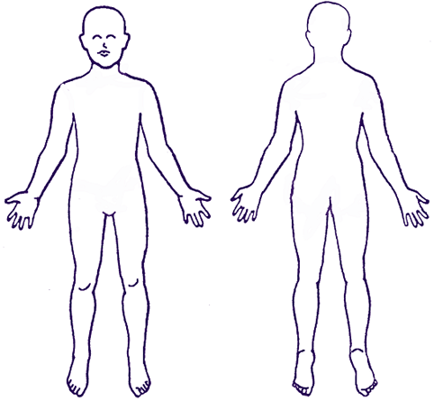

1. I understand that although massage can be very therapeutic, relaxing and reduce muscular tension, it is not a substitute for medical examination, diagnosis and/or treatment.
2. I understand that it is my responsibility to communicate any physical or emotional discomfort during the massage session. This includes room temperature, music, and depth of pressure.
3. I understand that this is a therapeutic massage and any sexual remarks or advances will immediately terminate the session and I am liable for payment in full for the scheduled session time.
4. Payment is due at the time of service.
5. There is a minimum of a 24 hour cancellation notice required. If I fail to cancel within the 24 hour period, or fail to no show, I understand that I will still be liable to pay for the booked session amount.
6. If I show up late, the length of the session will only be for the allotted time of the original session.
7. Proper draping standards will always be observed.
8. Prepaid sessions expire 2 years after they are bought.
9. I confirm I have answered all questions pertaining to medical questions truthfully.

Signature_________________________________________ Date___________________